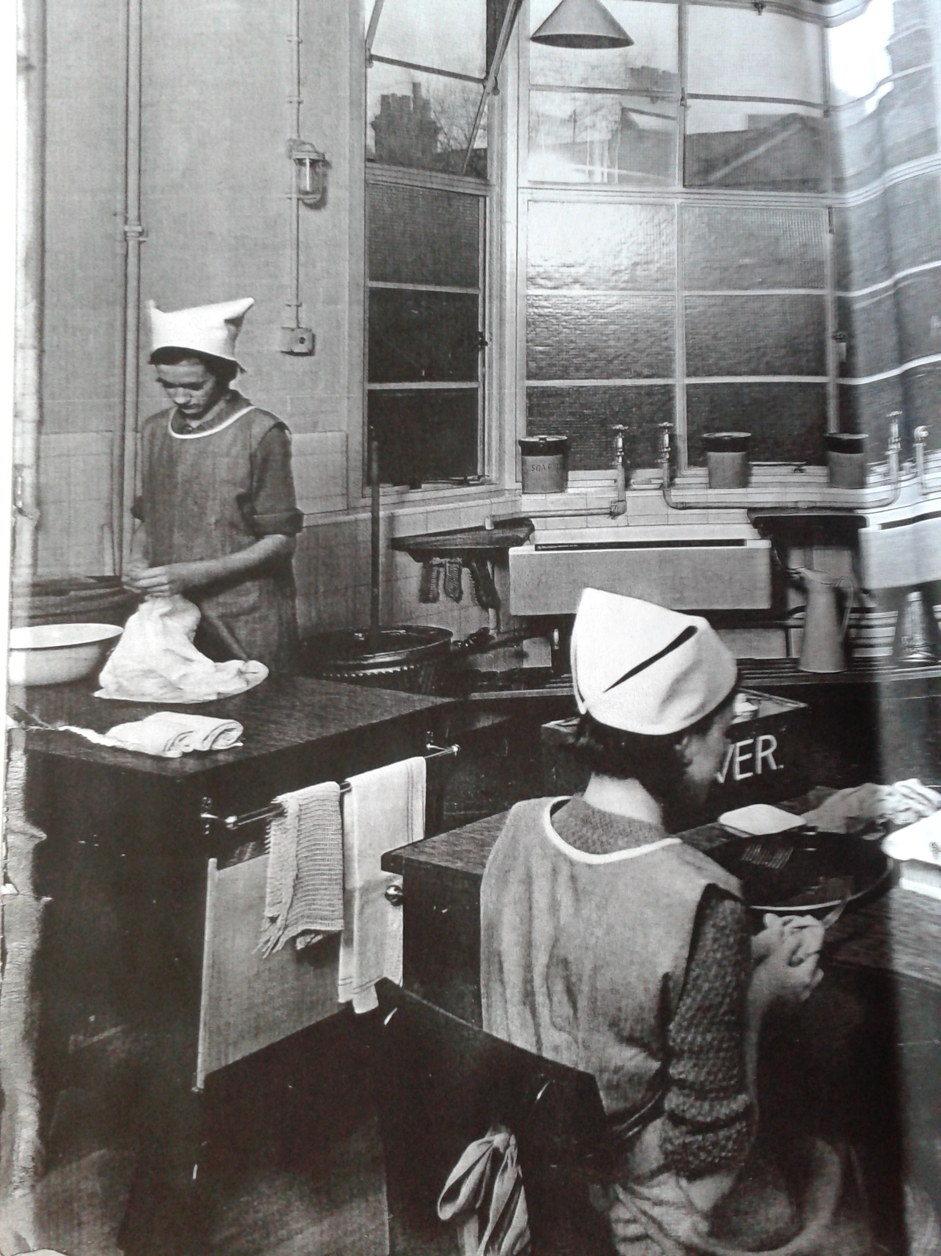

Figure 1 : Scene from a home economics class at the West Kensington Central School, 1930s, where on the windowsill are three large containers. The one on the right hand side is labelled "SODA" Institute of Education Archives, Newsam Library, BF1/1/33

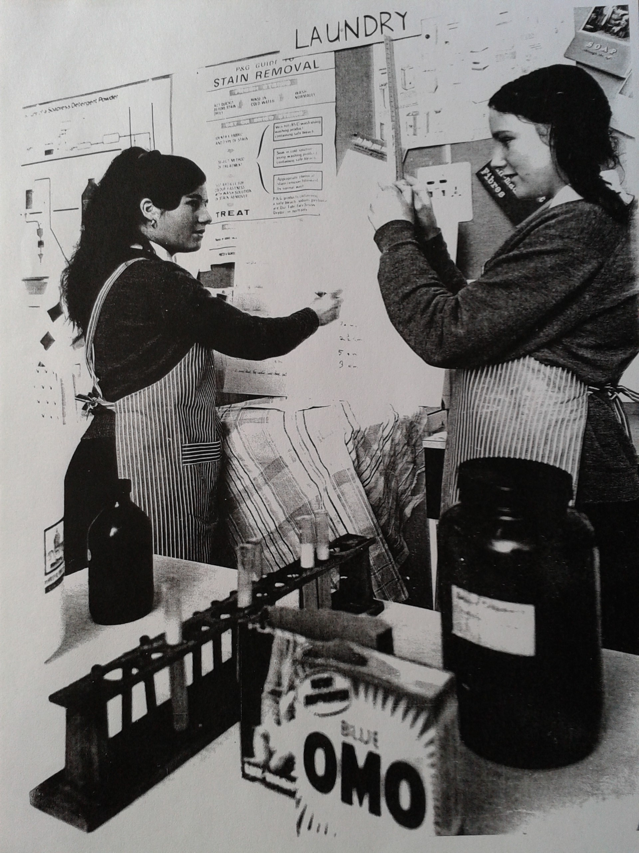

Figure 2: Photograph of a domestic science lesson in 1968. The pupils were measuring the height of foam produced from detergents, and the effect of water hardness adjusted by sodium carbonate on this. On the classroom wall behind them is a poster

In keeping with this reduced profile of washing soda and in contrast to the large jars of soda from the 1930s classroom, Illustration 3 shows a scene from a lesson in 1968 and shows that the nature of how soda was experienced had changed considerably. Soda was retrieved from a brown glass chemical jar in a precise manner by spatula, rather than grabbed by the handful from a jar as it had previously. While the pupils learned that technically soda softens water and enhances the work of detergent, measured by the height of detergent foam in their tried and tested experiment, they were becoming distanced from the bulk, everyday use of multipurpose washing soda and the domestic measurements it was described in. Washing soda was transformed into a carefully handled experimental chemical, sodium carbonate.

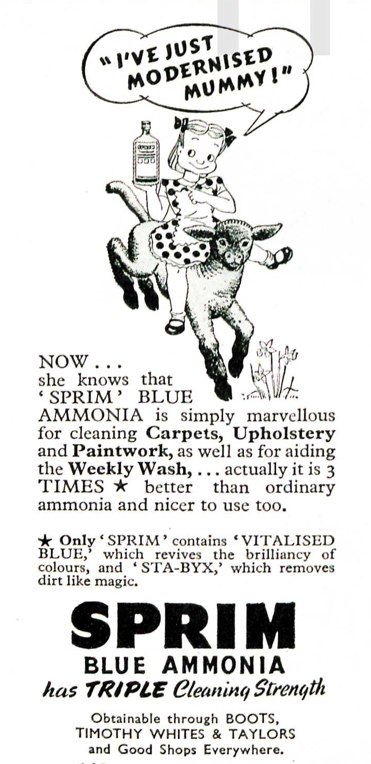

Figure 3Sprim ammonia advert, from Good Housekeeping Magazine April 1950 p142

While newspapers occasionally carried adverts for washing soda, readers of women's magazines were even less likely to see adverts for this product, despite the suggestions that were routinely found in women's magazines routine to use washing soda. This suggests that advertising budgets were thought to work harder promoting formulated and therefore more expensive cleansers, a hypothesis which is supported the by the presence of adverts for branded household ammonias, which suggests that added complexity through added ingredients meant column inches in the case of Sprim Blue Ammonia (Illustration 5). This was advertised as containing two additional products 'Vitalised Blue' and 'Sta-Byx' that were evidently known and desired additives or products in their own right which therefore made Sprim more attractive to users. Without such additions, well known, ubiquitous washing soda was not ordinarily worth advertising.

Soda combined with sloppy washing up was also blamed for bad tasting dishes, “A Housewife of Thirty Years Standing” hypothesised that rancid grease was released by soda added to vegetables which tainted the meal.

[1]"He Went to Buy Bicarb - Got Caustic Soda Instead." *Daily Mirror*, 24 June 1949,

1. "He Went to Buy Bicarb - Got Caustic Soda Instead." *Daily Mirror*, 24 June 1949,